Roll No: CB.SC.U4CSE24752
Name: Sivasubramani K J
Table name - auth_group
Fields for the table:
1. id
2. name
3. role
4. department
5. location
Sample corpus data for the table:
1. bike_admin, admin, operations, Bengaluru
2. sales_manager, manager, sales, Hyderabad
3. inventory_staff, staff, inventory, Coimbatore
4. finance_officer, officer, finance, Mysuru
5. customer_support, support, customer_service, Kochi
6. service_manager, manager, service, Bengaluru
Sample query text that will be provided:
1. Find all admins in Bengaluru.
2. List the managers working in sales and service departments.
3. Show the employee names with locations and roles.
NER details:
Named Entity Recognition (NER) is used to identify important entities in text such as names, locations, roles, and departments. In this dataset, words like bike_admin, sales_manager, Bengaluru, Hyderabad, finance, and customer_service can be treated as named entities or domain-specific entities. NER helps in extracting useful information from text and understanding how user roles and locations are represented in the corpus. It is useful for recognizing structured data within unstructured natural language sentences.
CFG output:
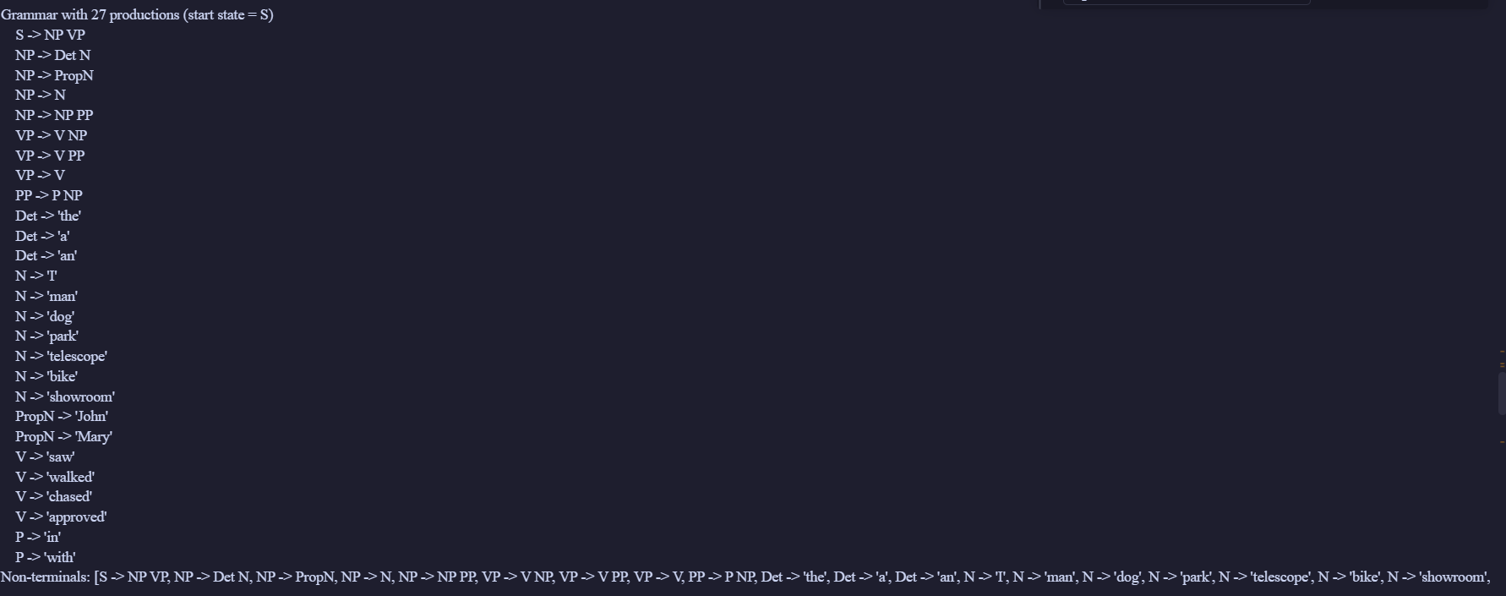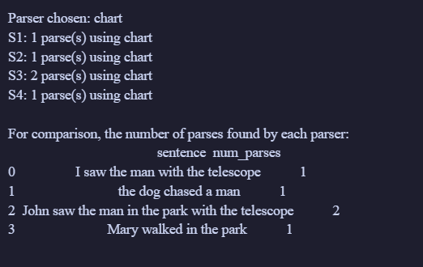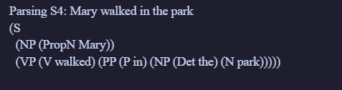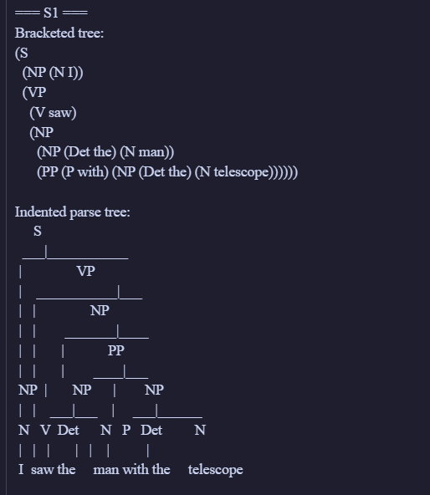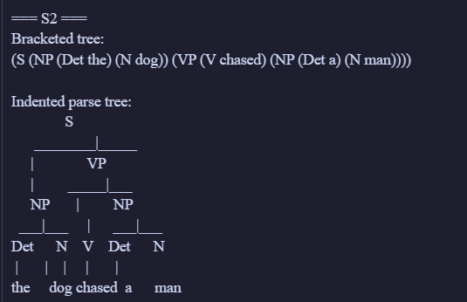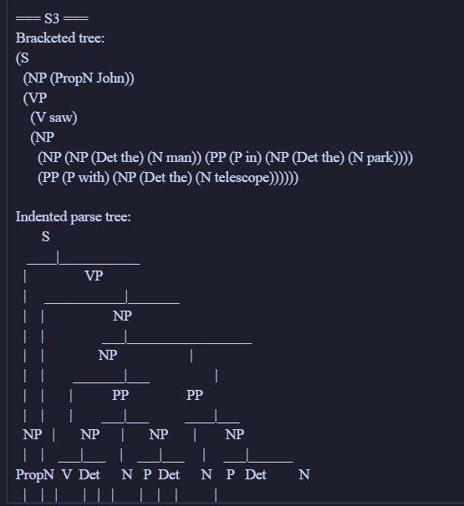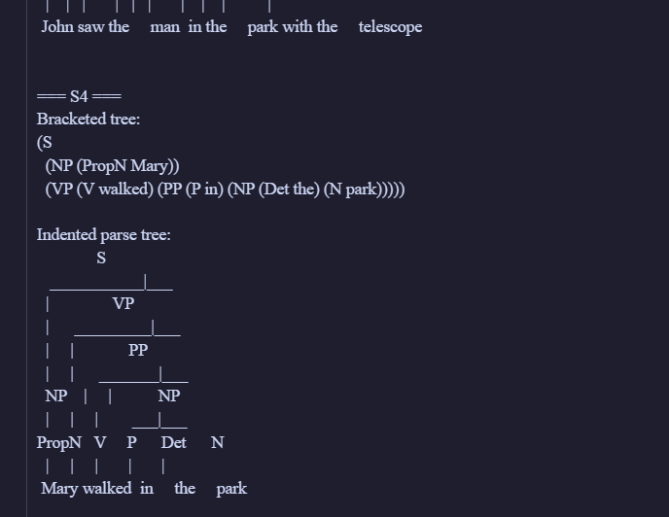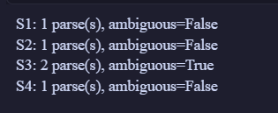
BERT output:
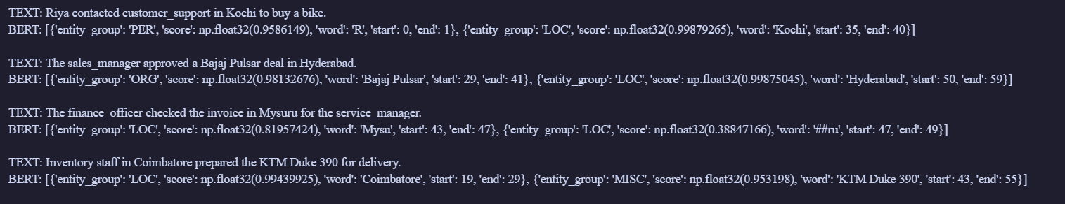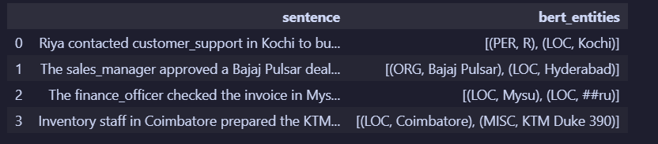
Understanding :
The model helps us understand text by detecting important entities, relationships, and patterns in the given corpus. NER identifies key words and labels them according to their meaning, while CFG provides a grammatical structure for sentences by showing how words are grouped into phrases. BERT is a transformer-based language model that understands the context of words in a sentence and can be used for text classification, question answering, and semantic analysis. Its output helps in interpreting the meaning of the input more accurately than simple keyword matching. This makes it useful for analyzing structured and unstructured language data in NLP tasks.
Also since the Bert uses Attention rather than sequential memory that were used my traditional neural networks it performs better at identifying dependencies and entities.

